**Spotify's Streaming Analytics**

**Mini Project Report**

**Of**

**Big Data Analytics**

Submitted in partial fulfillment of the requirements for the degree of

**Bachelor of Engineering (Computer Engineering)**

by:

|  |  |
| --- | --- |
| Anjali C. Shinde. | TU3F2122159 |
| Harsh A. Minde. | TU3F2122164 |

**Under the Guidance of**

**Dr. D. M. Bavkar.**



**Department of Computer Engineering**

**TERNA ENGINEERING COLLEGE**

Nerul (W), Navi Mumbai 400706

**(University of Mumbai)**

(2024-2025)



**TERNA ENGINEERING COLLEGE, NERUL,**

**NAVI MUMBAI**

**Department of Computer Engineering**

Academic Year 2024-25

**CERTIFICATE**

This is to certify that the mini project entitles **“Spotify's Streaming Analytics”** is a bonafide work of

**Anjali C. Shinde. ID No: TU3F2122159**

**Harsh A. Minde. ID No: TU3F2122164**

submitted to the University of Mumbai in partial fulfillment of the requirement for the award of the Bachelor of Engineering (Computer Engineering).

**Guide Head of Department Principal**

**Project Report Approval**

This Mini Project Report – an entitled “**Spotify's Streaming Analytics**” by following students is approved for the degree of **B.E. in "Computer Engineering"**.

**Submitted by:**

|  |  |
| --- | --- |
| Anjali C. Shinde. | TU3F2122159 |
| Harsh A. Minde. | TU3F2122164 |

Examiners Name & Signature:

1.---------------------------------------------------------

2.----------------------------------------------------------

Date: ---------------------------------

Place: ---------------------------------

**Declaration**

We declare that this written submission represents our ideas in our own words and where others' ideas or words have been included, we have adequately cited and referenced the original sources. We also declare that we have adhered to all principles of academic honesty and integrity and have not misrepresented or fabricated or falsified any idea/data/fact/source in our submission. We understand that any violation of the above will be cause for disciplinary action by the Institute and can also evoke penal action from the sources which have thus not been properly cited or from whom proper permission has not been taken when needed.

|  |  |  |
| --- | --- | --- |
| Anjali C. Shinde. | TU3F2122159 | --------------------------- |
| Harsh A. Minde. | TU3F2122164 | --------------------------- |

Date: \_\_\_\_\_\_\_\_\_\_\_\_\_\_\_\_\_\_\_\_\_

Place: \_\_\_\_\_\_\_\_\_\_\_\_\_\_\_\_\_\_\_\_\_

**Acknowledgement**

We would like to express our sincere gratitude towards our guide **Dr. D. M. Bavkar**, guidance and encouragement, they provided during the project development. This work would have not been possible without their valuable time, patience and motivation. We thank them for making my stint thoroughly pleasant and enriching. It was great learning and an honor being their student.

We are deeply thankful to **Prof. Kishor Sakure (H.O.D Computer Department)** and entire team in the Computer Department. They supported us with scientific guidance, advice and encouragement, they were always helpful and enthusiastic and this inspired us in our work.

We take the privilege to express our sincere thanks to **Dr. L. K. Ragha**our Principal for providing the encouragement and much support throughout our work.

|  |  |
| --- | --- |
| Anjali C. Shinde. | TU3F2122159 |
| Harsh A. Minde. | TU3F2122164 |

Date: \_\_\_\_\_\_\_\_\_\_\_\_\_\_\_\_\_\_\_\_\_

Place: \_\_\_\_\_\_\_\_\_\_\_\_\_\_\_\_\_\_\_\_\_

**Abstract**

This project provides an analytical exploration of Spotify's "Top 200" and "Viral 50" music charts from 2019 to 2021, aiming to uncover key trends in song popularity, artist representation, and regional streaming behavior. Leveraging a large dataset, the analysis delves into how different artists, tracks, and regions contribute to global streaming dynamics, focusing on factors influencing music virality.

The project was conducted using the R programming language and its libraries for data visualization, including ggplot2 and dplyr, which facilitated detailed examinations of streaming data across several dimensions. Total streams were assessed over time, with particular attention to top-performing artists and songs, as well as geographical distribution of streams. By analyzing the number of streams globally and across specific regions, this project offers insights into the cultural and regional differences that shape the music industry today.

Key findings of the analysis include a ranking of the most popular artists and songs by total streams, a geographical breakdown of listening habits, and the discovery of trends that persisted or fluctuated throughout the study period. Additionally, an exploration of how specific trends, such as "MOVE\_UP," "MOVE\_DOWN," "NEW\_ENTRY," and "SAME\_POSITION," impacted song performance was carried out to illustrate streaming volatility.

This project provides valuable insights into the intersection of big data analytics and the music industry, highlighting the potential for such analyses to inform both strategic decision-making for artists and record labels and to understand the evolving preferences of listeners across the world. It demonstrates how digital platforms like Spotify offer a rich source of data for tracking musical influence and consumer behavior over time.

**Table of Contents**

|  |  |  |  |  |  |  |  |  |  |  |  |  |  |  |  |  |  |  |  |  |  |  |  |  |  |  |  |  |  |  |  |  |  |  |  |  |  |  |  |  |  |  |  |  |  |  |  |  |  |  |  |  |  |  |  |  |  |  |  |  |  |  |  |  |  |  |  |  |  |  |  |  |  |  |  |  |  |  |  |  |  |  |  |  |  |  |  |  |  |  |  |  |  |  |  |  |  |  |  |  |  |  |  |  |  |  |  |  |  |  |  |  |  |  |  |  |  |  |  |  |  |  |  |  |  |  |  |  |  |  |  |  |  |  |  |  |  |  |  |  |  |  |  |  |  |  |  |  |  |  |  |  |  |  |  |  |  |  |  |  |  |  |  |  |  |  |  |  |  |  |  |  |  |  |  |  |  |  |  |  |  |  |  |  |  |  |  |  |  |  |  |  |  |  |  |  |  |  |  |
| --- | --- | --- | --- | --- | --- | --- | --- | --- | --- | --- | --- | --- | --- | --- | --- | --- | --- | --- | --- | --- | --- | --- | --- | --- | --- | --- | --- | --- | --- | --- | --- | --- | --- | --- | --- | --- | --- | --- | --- | --- | --- | --- | --- | --- | --- | --- | --- | --- | --- | --- | --- | --- | --- | --- | --- | --- | --- | --- | --- | --- | --- | --- | --- | --- | --- | --- | --- | --- | --- | --- | --- | --- | --- | --- | --- | --- | --- | --- | --- | --- | --- | --- | --- | --- | --- | --- | --- | --- | --- | --- | --- | --- | --- | --- | --- | --- | --- | --- | --- | --- | --- | --- | --- | --- | --- | --- | --- | --- | --- | --- | --- | --- | --- | --- | --- | --- | --- | --- | --- | --- | --- | --- | --- | --- | --- | --- | --- | --- | --- | --- | --- | --- | --- | --- | --- | --- | --- | --- | --- | --- | --- | --- | --- | --- | --- | --- | --- | --- | --- | --- | --- | --- | --- | --- | --- | --- | --- | --- | --- | --- | --- | --- | --- | --- | --- | --- | --- | --- | --- | --- | --- | --- | --- | --- | --- | --- | --- | --- | --- | --- | --- | --- | --- | --- | --- | --- | --- | --- | --- | --- | --- | --- | --- | --- | --- | --- | --- | --- | --- |
| |  |  |  | | --- | --- | --- | | **Sr. No.** | **Title** | **Page No.** | |  | **Abstract** | i. | |  | **List of Figures** | ii. | |  | **List of Abbreviations** | iii. | | **Chapter 1** | **Introduction** | 11. | |  | * 1. Introduction | 11. | |  | 1.2 Organization of the Report | 12. | | **Chapter 2** | **Literature Survey** | 14. | |  | 2.1 Problem Statement | 14. | |  | 2.2 Existing System Survey | 15. | |  | 2.3 Objectives | 16. | |  | 2.4 Scope of the Project | 17. | | **Chapter 3** | **Software Analysis and Design** | 18. | |  | 3.1 Software Model | 18. | |  | 3.1.1 Phases of Software Model | 19. | |  | 3.2 Proposed System | 21. | |  | 3.3 System Requirement Specification | 22. | |  | 3.4 Hardware and Software Requirements | 23. | |  | 3.5 Design | 24. | |  | 3.5.1 Gantt Chart | 24. | |  | 3.5.2 Data Flow Diagrams | 24. | |  | 3.5.3 Flowchart Diagram | 25. | |  | 3.5.4 Sequence Diagram | 26. | |  | 3.6 RMMM | 26. | | **Sr. No.** | **Title** | **Page No.** | | **Chapter 4** | **Methodology** | 34. | |  | 4.1 Experimental Setup | 34. | |  | 4.1.1 Description of Data | 35. | |  | 4.1.2 Methodology used to Perform Experiment | 35. | |  | 4.1.3 Tools and Libraries Used | 38. | |  | 4.2 Experimental Design | 38. | |  | 4.3 Challenges and Mitigation Strategies | 39. | |  | 4.4 Statistical Tools and Techniques | 40. | | **Chapter 5** | **Result and Discussion** | 41. | |  | 5.1 Total Streams Over Time (2019-2021) | 41. | |  | 5.2 Top 10 Artists by Total Streams | 43. | |  | 5.3 Top 10 Songs by Total Streams | 44. | |  | 5.4 Total Streams by Region | 46. | |  | 5.5 Average Streams by Region | 47. | |  | 5.6 Heatmap of Total Streams by Top 20 Artists and Regions | 49. | |  | 5.7 Total Streams Distribution Across Trend | 50. | |  | 5.8 Boxplot of Streams by Trend Category | 52. | |  | 5.9 Streams by Region Over Time | 54. | |  | 5.10 Total Streams by Region Map | 55. | | **Chapter 6** | **Conclusion** | 57. | |  | 6.1 Summary | 57. | |  | 6.2 Conclusion | 57. | |  | 6.3 Future Work | 58. | |  | **References** | 60. |   **List of Figures**   |  |  |  | | --- | --- | --- | | **Sr. No.** | **Title** | **Page No.** | | 1. | Fig 3.1 Software Model | 18. | | 2. | Fig 3.5.1 Gantt Chart (Timeline) | 24. | | 3. | Fig 3.5.2 Data Flow Diagram | 24. | | 4. | Fig 3.5.3 Flowchart Diagram | 25. | | 5. | Fig 3.5.4 Sequence Diagram | 26. | | 6. | Fig 4.1 System Overview | 34. | | 7. | Fig 5.1 Summary of Key Metrics (2019-2021) | 41. | | 8. | Fig 5.2 Ranking of Top Artists by Total Streams | 43. | | 9. | Fig 5.3 Ranking of Top Songs by Total Streams | 44. | | 10. | Fig 5.4 Total Streams by Region and Year | 46. | | 11. | Fig 5.5 Average Streams by Region | 47. | | 12. | Fig 5.6 Trend Analysis of Streaming Behavior | 49. | | 13. | Fig 5.7 Challenges Faced During Analysis and Mitigation Strategies | 50. | | 14. | Fig 5.8 Software and Hardware Requirements | 52. | | 15. | Fig 5.9 Tools and Libraries Used in Analysis | 54. | | 16. | Fig 5.10 Statistical Techniques Applied in the Study | 55. | |  |

**List of Abbreviations**

|  |  |  |
| --- | --- | --- |
| **Sr. No.** | **Abbreviations** | **Full Form** |
| 1. | RMMM | Risk Mitigation and Management Model |
| 2. | API | Application Programming Interface |
| 3. | GDP | Gross Domestic Product |
| 4. | ML | Machine Learning |
| 5. | DB | Database |
| 6. | CSV | Comma-Separated Values |
| 7. | ggplot2 | Grammar of Graphics for R |
| 8. | dplyr | Data Manipulation in R |
| 9. | EDA | Exploratory Data Analysis |

**Chapter 1**

**Introduction**

**1.1 Introduction:**

The rise of digital platforms has transformed the way people access music, and among these platforms, Spotify stands out as one of the most influential. With its global user base, Spotify generates an enormous amount of data daily, particularly through its popular charts such as the "Top 200" and "Viral 50." These charts reflect music consumption on a massive scale, providing valuable insights into how listeners engage with songs and artists over time. The data from these charts reveals not just individual preferences, but broader patterns in the music industry, including regional listening trends and viral music phenomena.

From 2019 to 2021, the global music landscape underwent significant shifts, influenced by changes in streaming behavior, social media virality, and the evolving tastes of listeners. By analyzing Spotify’s daily chart data over this period, it is possible to uncover trends that provide a deeper understanding of the dynamics of the music industry. This project aims to achieve just that, focusing on two key Spotify datasets: the "Top 200" (which ranks the most streamed songs in a given day) and the "Viral 50" (which measures the virality of songs based on factors like social sharing and user interaction).

The primary goal of this project is to explore patterns in song and artist popularity, regional streaming behaviors, and trends across different time periods. By identifying the top-performing artists and songs, we can understand the factors driving consistent success. Additionally, by analyzing data on a regional basis, we aim to discover how music consumption varies geographically, shedding light on the cultural nuances of different countries and regions. Furthermore, the analysis of "viral" trends reveals insights into the nature of modern virality, a phenomenon often driven by platforms such as TikTok and YouTube, alongside traditional media.

This project utilizes R programming, a powerful tool for data analysis and visualization. By leveraging libraries such as ggplot2, dplyr, and lubridate, we create visualizations that offer clear insights into the data. The focus is not only on raw data analysis but also on creating visual representations that are easy to interpret. These visualizations cover aspects such as the total number of streams over time, the dominance of specific artists and songs, regional differences in streaming habits, and the nature of viral trends.

Ultimately, this analysis seeks to provide a comprehensive view of the streaming ecosystem between 2019 and 2021, helping us understand what factors contribute to a song's success, both in terms of popularity and virality. Through this project, we gain insights that are valuable not only for industry professionals but also for music enthusiasts interested in the data-driven side of entertainment.

**1.2 Organization of the Report:**

This project report is systematically organized into the following chapters:

1. **Introduction:**  
   Provides an overview of the digital music industry, the significance of data analytics in understanding music consumption trends, and the objectives of the study. It outlines the focus on Spotify’s "Top 200" and "Viral 50" charts for the period 2019-2021 and discusses the motivation for using R programming for data analysis and visualization.
2. **Literature-Survey:**  
   Reviews existing literature on data visualization techniques in music analytics, key trends in the music streaming industry, and relevant studies on song popularity and viral trends. This chapter also examines the analytical tools and methods previously used in similar studies.
3. **Existing-Systems:**  
   Discusses the current state of music streaming data analysis, including the use of proprietary systems by major streaming platforms. It also highlights the limitations of these systems, particularly in terms of accessibility for independent analysis and insights generation.
4. **Proposed-System:**  
   Introduces the methodology and framework adopted for this project, including the use of R programming and various libraries for data cleaning, analysis, and visualization. The proposed system's advantages in terms of scalability, flexibility, and clarity are also discussed.
5. **Data-Description-and-Experimental-Setup:**  
   Describes the dataset used in the project, including its structure, variables, and time period. It also details the experimental setup, outlining the steps taken to clean, preprocess, and prepare the data for analysis. The tools and techniques used, including R libraries like ggplot2, dplyr, and tidyr, are explained.
6. **Results-and-Discussion:**  
   Presents the key findings from the analysis, including visualizations of song and artist performance, regional streaming patterns, and trends in viral songs. This chapter also includes interpretations of the results, discussing the factors that influence the popularity and virality of songs across different regions.
7. **Conclusion-and-Future-Work:**  
   Summarizes the main findings of the project and discusses their implications for the music industry. It also identifies potential improvements for future analyses, such as expanding the dataset or using machine learning techniques to predict future trends.

**Chapter 2**

**Literature Survey**

**2.1 Existing System Survey:**

The existing research and systems around music streaming trends have primarily focused on various aspects of user engagement and streaming patterns. Streaming platforms like Spotify, Apple Music, and YouTube release charts such as Spotify’s "Top 200" and "Viral 50," which track daily and weekly trends. However, these platforms' analytical tools often fall short in terms of providing deep, comprehensive insights into trends at a global level. They tend to focus on specific metrics such as user activity, total playtime, and regional streaming statistics.

Despite the availability of these charts, the existing systems face several limitations:

1. **Single Region Focus:**

Most analyses are confined to one region or country. For example, trends are examined in the context of the US or Europe without giving much insight into the global impact or cross-regional trends. This creates gaps in understanding how viral content moves across countries and cultural contexts.

1. **Short Timeframes:**

Many existing systems evaluate trends over a short time period, usually limited to weeks or months. Long-term studies that span years and offer insights into shifts in musical tastes, artist performance, or song longevity are rare.

1. **Viral Song Tracking:**

Viral trends are particularly hard to track across multiple regions. Existing platforms lack comprehensive features that analyze how a song becomes viral and whether it remains so across different regions. Viral trends are often short-lived and do not get consistent focus in traditional research systems.

1. **Data Accessibility and Insights Generation:**

Many of the streaming platforms have proprietary systems that make it difficult for independent analysts to access and analyze the data. These systems provide high-level visualizations but often lack flexibility, customization, and detailed analysis features.

1. **Lack of Visualization Depth:**

While platforms offer basic statistics and charts, they often don’t go beyond surface-level insights. There is a need for more complex visualizations that reveal deeper patterns, such as how certain songs or artists perform over time, the interplay between global and regional trends, and the correlation between different variables like region, streams, and virality.

1. **Insufficient Historical Data**:

Much of the existing research has focused on recent data, often ignoring the historical context of music trends. As a result, it becomes difficult to study how certain genres or artists evolve over time, missing the opportunity to understand long-term shifts in the music industry.

Given these limitations, the need for a comprehensive system that can analyze Spotify's streaming charts globally over a multi-year period is evident. Such a system would offer in-depth insights into the factors driving music trends and virality on a global and regional scale.

**2.2 Problem Statement:**

This project aims to address the limitations of existing systems by performing an in-depth analysis of global streaming data from Spotify’s "Top 200" and "Viral 50" charts between 2019 and 2021. The study will focus on:

* **Understanding song performance** based on total streams and the temporal patterns of streaming trends over time.
* **Analyzing the distribution of streams** across multiple regions and exploring how different regions contribute to overall trends.
* **Identifying key artists and songs** that have played a major role in driving viral trends during this period.
* **Exploring the relationship between streaming trends and regional consumption patterns**, offering insights into how cultural and geographical factors affect music preferences.

Through data analysis and visualization using R programming, the project will provide valuable insights into the music streaming landscape.

**2.3 Objectives:**

The primary objectives of this project are:

1. **Analyze global streaming data** from Spotify to uncover key trends in the "Top 200" and "Viral 50" charts over the years 2019 to 2021.
2. **Identify top-performing songs and artists** both globally and regionally, showcasing their total streams, popularity, and how they have impacted the music industry.
3. **Visualize the temporal patterns** in song streams, illustrating how these trends evolve over time and how certain songs maintain their popularity while others fluctuate.
4. **Highlight the factors that influence viral success**, examining how songs become viral and sustain their positions in the charts.
5. **Explore regional differences in music consumption**, identifying how various regions contribute to global music trends and examining patterns in regional preferences.
6. **Provide actionable insights** for stakeholders in the music industry, including artists, record labels, and marketers, on how to better understand the factors driving global and regional music trends.

**2.4 Scope:**

This project focuses on analyzing data from Spotify’s global "Top 200" and "Viral 50" charts between the years 2019 and 2021. Key aspects covered include:

* **Total Streams:** Examination of the total number of streams per song and artist, providing a comparative analysis over time.
* **Artist and Song Performance:** Identifying top-performing artists and songs, both globally and across different regions.
* **Regional Behavior:** Analyzing how music consumption differs across regions and how viral trends emerge within specific areas.
* **Data Visualization:** Using R programming to generate detailed visualizations that effectively communicate trends in the music streaming landscape. Libraries such as ggplot2, dplyr, tidyr, and lubridate are used to process and visualize the dataset.

This analysis will offer a comprehensive understanding of music streaming trends on a global scale, providing insights into the dynamics of song virality, regional preferences, and the overall influence of global streaming patterns on the music industry.

**Chapter 3**

**Software Analysis and Design**

This chapter focuses on the in-depth analysis and design of the software solution for **Spotify Charts Data Visualization using R programming**. It explains the architecture, software development lifecycle model, system requirements, design diagrams, and risk mitigation plans essential to developing a robust and scalable solution.

**3.1 Software Model:**

**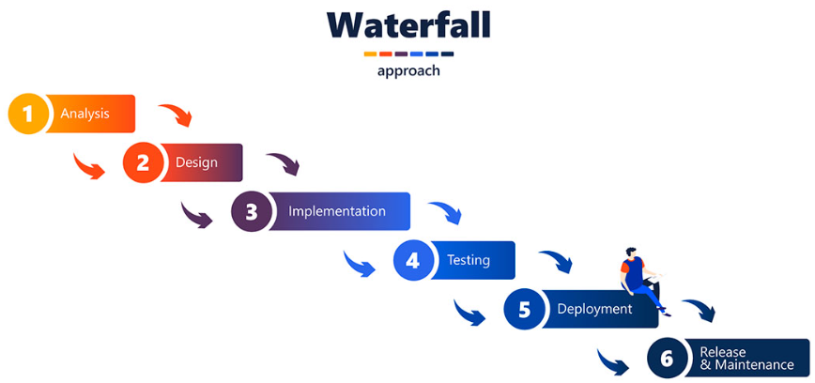**

Fig 3.1 Software Model

A well-structured software model is essential for managing the complexity of software development, particularly in data-heavy projects. In this project, the **Waterfall Model** was selected due to its linear and systematic approach, making it ideal for projects with well-defined requirements and a clear timeline. Each phase in the Waterfall Model is distinct, with its own set of deliverables, ensuring that tasks are completed sequentially before moving on to the next.

**3.1.1 Phases of the Software Model:**

1. **Requirement Gathering and Analysis:**

This phase is pivotal in determining the project’s scope, objectives, and data needs. The dataset used for this project was sourced from **Kaggle**, containing data from Spotify’s 'Top 200' and 'Viral 50' charts from 2019 to 2021. Key attributes of this dataset include song titles, artist names, streaming counts, trends, regions, and dates. The primary objective was to analyze streaming behavior, song and artist popularity, regional streaming patterns, and trends in the music industry.

1. **System Design:**

The architecture of the system was laid out, involving both hardware and software components. The system was designed to run on local machines, utilizing **R programming** for data visualization. The key design elements included:

* + - **Data pipeline:**

Loading, cleaning, and processing the CSV file from Kaggle.

* + - **Visualization:**

Rendering insights through **ggplot2** for graphical representations of trends, and **dplyr** for data manipulation.

* + - **Database Design:**

No explicit database was involved; data was handled directly from the CSV file. However, for scalability, a potential integration with cloud databases like Firebase or MongoDB could be envisioned.

1. **Implementation:**

During the implementation phase, the core features of the project were developed. The system was implemented using **R** programming, utilizing key packages such as:

* + - **ggplot**2: For creating various charts and graphs.
    - **dplyr:** For efficient data manipulation.
    - **reshape2:** To handle data reshaping for visualizations.
    - **lubridate:** For date manipulation, crucial for time-based analyses.
    - **tidyr:** For tidying up data before visualization.

The primary focus was on visualizing trends, top artists, top songs, and regional streaming behavior.

1. **Integration and Testing:**

Testing was a crucial phase in validating the integrity of the visualizations. Unit tests were implemented to ensure each chart, including bar plots, line graphs, and heatmaps, reflected accurate information. Integration testing was done to confirm that the different components of the system, such as data loading and visualization, worked harmoniously.

1. **Deployment:**

The project was tested and deployed on a local machine. R scripts were optimized for performance to handle large datasets. The visualizations were checked for efficiency, clarity, and ease of interpretation. While there was no live deployment, future deployment on cloud-based platforms like **Shiny** for interactive visualizations was considered.

1. **Maintenance:**

Maintenance of the project includes regular updates to handle new datasets, bug fixes, and feature enhancements. As the music industry is dynamic, integrating new data (e.g., charts from subsequent years) can be achieved by modifying the data input pipelines.

**3.2 Proposed System:**

The proposed system aims to provide deep insights into Spotify's streaming data by analyzing the 'Top 200' and 'Viral 50' charts from 2019 to 2021. Using **R programming**, the system visualizes key trends, top artists, and regional streaming behaviors through a variety of graphical formats. The objective is to offer a comprehensive understanding of how music streaming patterns evolve, the impact of regional preferences, and the dynamics of song popularity.

**Key Features of the System:**

1. **Total Streams Over Time (Yearly):**

The system offers a year-wise comparison of total streams between 2019 and 2021. By visualizing yearly total streams, it provides insights into the overall growth of music consumption on Spotify during the analyzed period.

1. **Top 10 Artists and Songs:**

A crucial feature of the system is identifying the **Top 10 artists** and **Top 10 songs** by total streams. These visualizations help in recognizing key players in the music industry, showcasing who dominated the charts during the given timeframe.

1. **Regional Analysis:**

The system breaks down streaming behavior by region, allowing a clear view of how musical preferences vary across different parts of the world. It includes heatmaps and line graphs to illustrate regional trends and changes over time.

1. **Trend Categorization:**

Streaming trends are categorized into key movements, such as **MOVE\_UP**, **MOVE\_DOWN**, **NEW\_ENTRY**, and **SAME\_POSITION**. This feature offers a deeper look at how songs fluctuate in popularity.

1. **Heatmaps and Line Graphs:**

The system includes **heatmaps** to visualize the interaction between regions and top artists and **line graphs** to display how streams vary over time in different regions.

By combining these features, the system provides a rich and detailed view of the music industry’s evolving landscape, offering valuable insights for both listeners and industry stakeholders.

**3.3 System Requirement Specification (SRS):**

**Functional Requirements:**

1. The system must load Spotify charts data from a CSV file.
2. It should process and clean the data to handle missing values and outliers.
3. The system must generate various visualizations, including **bar plots**, **line graphs**, **heatmaps**, and **boxplots**.
4. It must efficiently handle large datasets and perform data analysis in a time-efficient manner.
5. The system should be capable of generating real-time insights by processing data quickly.

**Non-Functional Requirements:**

1. **Performance:**

The system must be optimized to handle large volumes of data without significant lag. R's data manipulation libraries and efficient coding practices ensure the system’s performance remains high even when dealing with millions of records.

1. **Scalability:**

The system should allow for the integration of additional regions or extended time periods. Future versions should support datasets covering more years or real-time updates.

1. **Usability:**

The visualizations generated must be intuitive, providing clear and concise insights. All graphs and charts should be easy to interpret by non-technical stakeholders.

1. **Reliability:**

The system should function reliably under different data loads and ensure accuracy in the results of the visualizations.

1. **Portability:**

The code and visualizations should run seamlessly on different machines (Windows, Mac, Linux) with minimal setup. R's platform independence aids in ensuring portability.

**3.4 Hardware and Software Requirements:**

**Hardware Requirements:**

* **Processor:** Intel Core i5 or higher
* **RAM:** 8GB or higher
* **Disk Space:** Minimum 5GB for datasets and software
* **GPU:** Optional (for enhanced performance in data processing)

**Software Requirements:**

* **Operating System:** Windows 10 or Linux (Ubuntu)
* **Software:** R version 4.0.2 or higher
* **Libraries:** ggplot2, dplyr, reshape2, lubridate, tidyr, maps, mapdata
* **Tools:** RStudio for IDE, CSV for datasets

**3.5 Design:**

This section details the visual and structural design of the project, including diagrams like Gantt charts, Data Flow Diagrams (DFD), Use Case, and Sequence Diagrams.

**3.5.1 Gantt Chart:**

**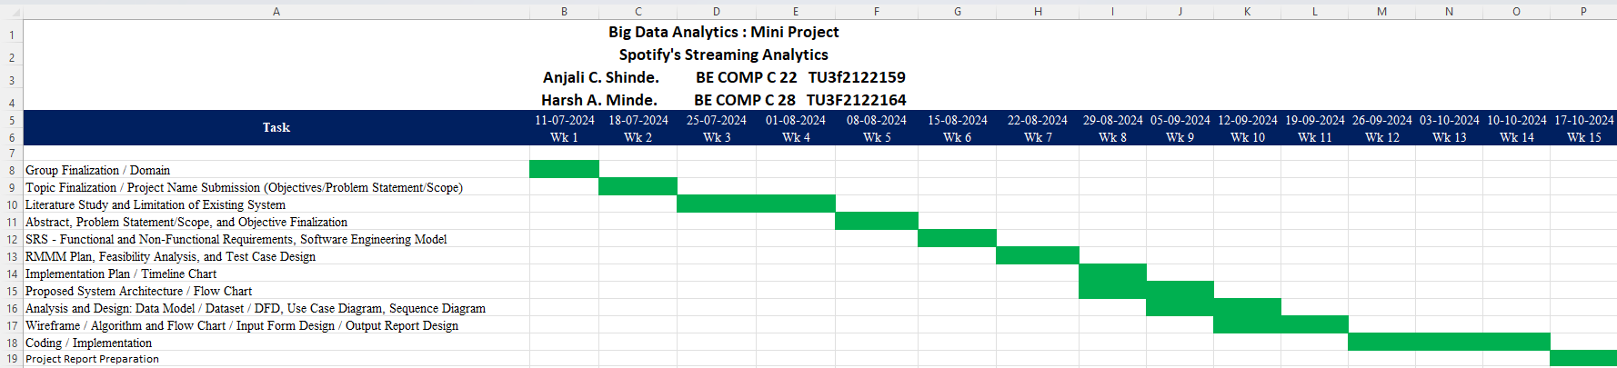**

Fig 3.5.1 Gantt Chart (Timeline)

A Gantt Chart is used to visualize the project timeline and milestones. Each phase of the software lifecycle, such as data collection, data cleaning, and visualization generation, was allotted specific durations. The chart also included dependencies between tasks, such as implementing code before testing or refining datasets.

**3.5.2 Data Flow Diagram (DFD):**

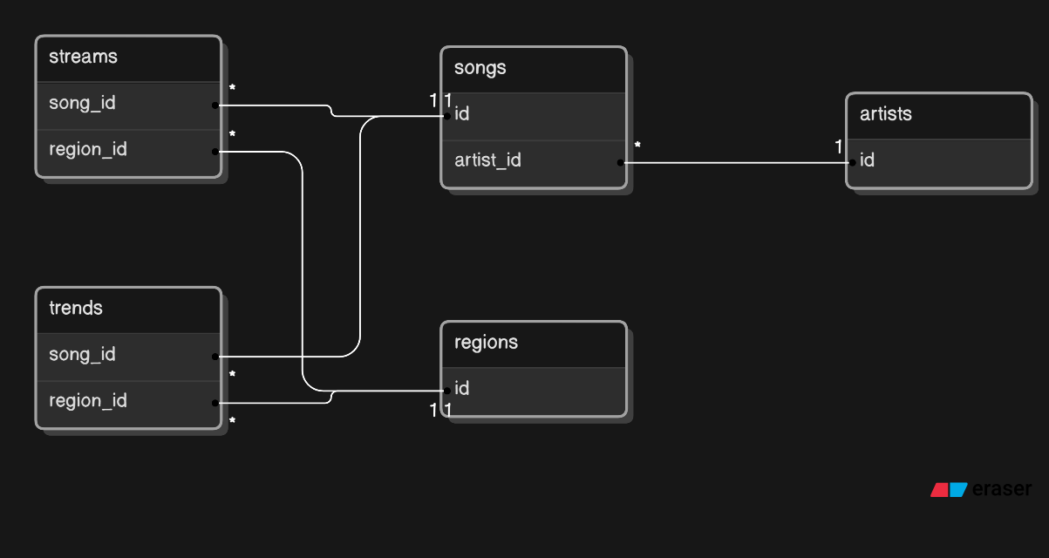

Fig 3.5.2 Data Flow Diagram

The Data Flow Diagram (DFD) outlines the flow of data between the user interface, backend systems, and the dataset repository. Key data flows:

* **Input:** Raw Spotify data in CSV format.
* **Processing:** R scripts handle data cleaning, transformations, & visualization generation.
* **Output:** Visual graphs and charts.

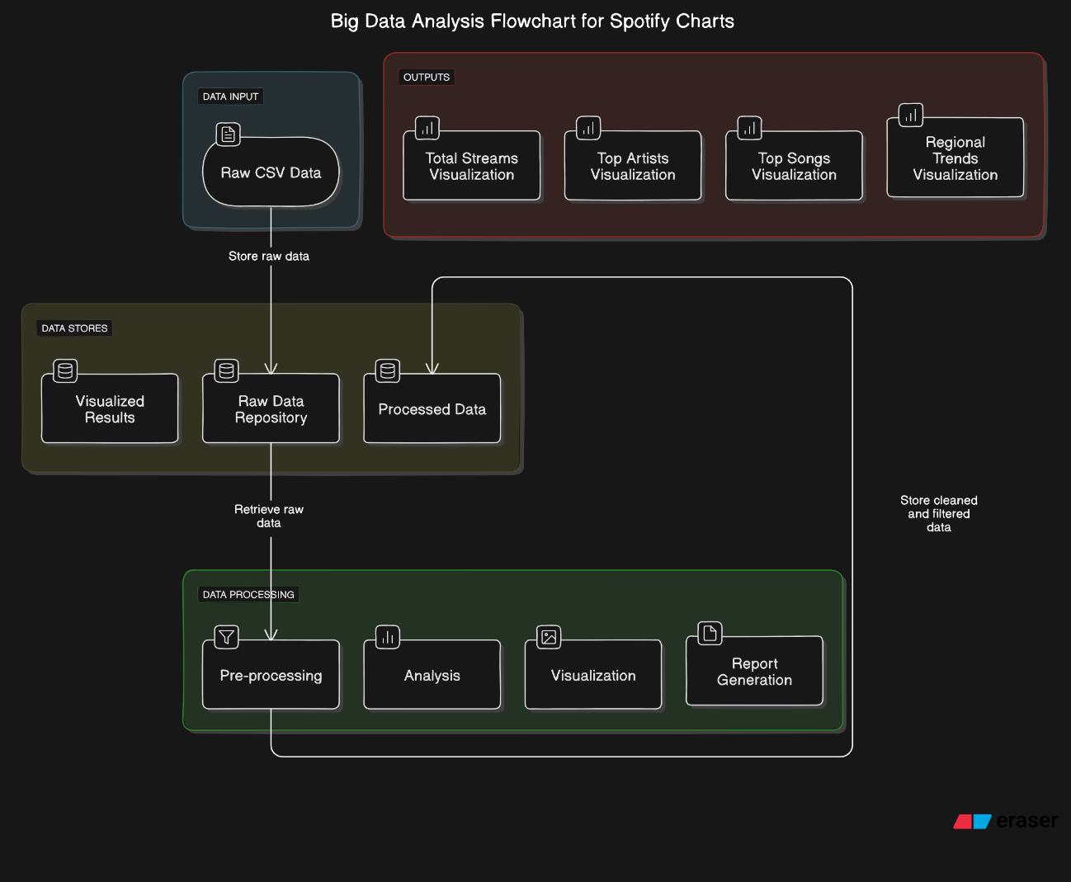**3.5.3 Flowchart Diagram:**

Fig 3.5.3 Flowchart Diagram

The Flowchart depicts the process flow from loading data to generating visualizations. It includes decisions like data filtering and missing value handling. Each box represents a step in the data processing pipeline.

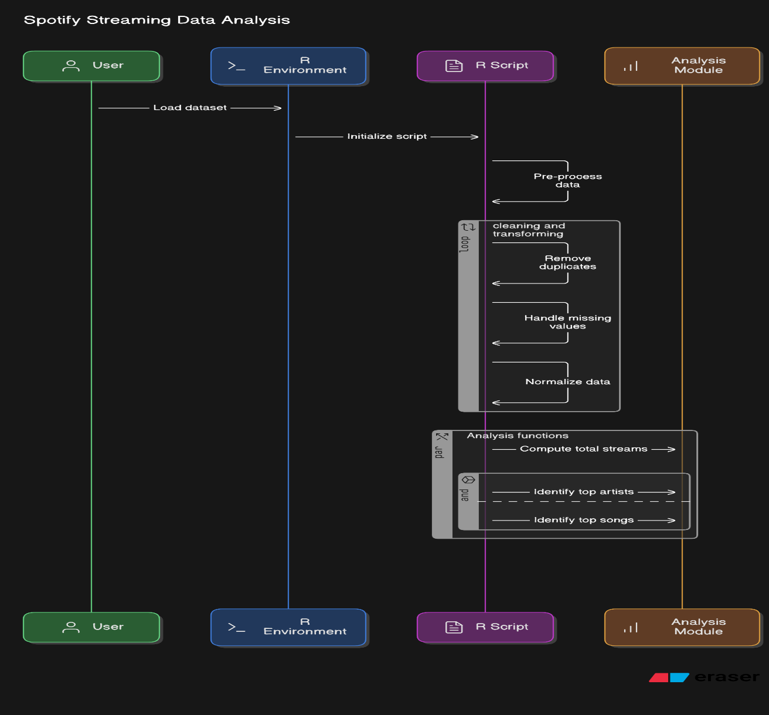**3.5.4 Sequence Diagram:**

Fig 3.5.4 Sequence Diagram

The Sequence Diagram shows the order of operations when processing and visualizing data. It begins with loading the dataset, followed by cleaning, transforming, and plotting. The diagram also highlights the interaction between R functions and libraries.

**3.6 Risk Mitigation, Monitoring, and Management Plan:**

In this Big Data Analysis project on Spotify's 'Top 200' and 'Viral 50' charts, several key risks were identified and managed throughout the project lifecycle. Below is a comprehensive breakdown of these risks, their potential impacts, and the mitigation strategies implemented to ensure successful project execution.

**1. Data Inconsistency:**

* **Risk Description:**

The dataset spans multiple regions and time periods, which could lead to incomplete, missing, or inconsistent data entries. This includes errors like missing values for certain song streams, discrepancies in region naming, or unexpected changes in the format of the dataset.

* **Potential Impact:**

Incomplete or incorrect data can lead to faulty insights, skewed visualizations, and unreliable conclusions. It might affect trend analysis, regional comparisons, or artist/song rankings.

* **Mitigation Strategies:**
  + **Data Preprocessing**:

A rigorous data cleaning process was performed using R libraries such as dplyr and tidyr. This included filtering rows with missing or incomplete entries and ensuring that all necessary columns (like streams, region, and date) contained valid data.

* + **Error Handling:**

Automated scripts to check for missing or invalid data in real-time during data importation and processing were implemented. These checks minimized the chances of faulty records affecting analysis.

* + **Data Transformation:**

The use of functions to transform data (e.g., converting dates to consistent formats, ensuring uniform naming conventions for regions, artists, and songs) improved overall consistency and accuracy.

**2. Performance Issues:**

* **Risk Description:**

Handling large datasets (millions of records over several years) is computationally expensive, especially during data transformation and visualization processes. Complex plots, such as heatmaps and trend analysis, could potentially lead to performance bottlenecks.

* **Potential Impact:**

Performance issues could result in long execution times for scripts, slow rendering of visualizations, or, in severe cases, crashes due to insufficient memory or CPU capacity. This would slow down analysis and hinder the exploration of trends in the data.

* **Mitigation Strategies:**
  + **Efficient Libraries:**

The project utilized high-performance R libraries like ggplot2, dplyr, and reshape2 to handle data efficiently. These libraries are optimized for handling large datasets and were critical in ensuring smooth processing.

* + **Data Filtering:**

To reduce the computational load, only necessary data (e.g., specific regions, time periods, or top artists) was filtered and processed during analysis. This significantly minimized the size of data subsets used for each visualization.

* + **Caching Intermediate Results:**

Intermediate results, such as transformed data or computed summaries, were cached and reused in multiple stages of analysis to avoid recomputation and enhance overall system performance.

* + **Memory Optimization:**

The use of memory-efficient data structures and timely removal of unused objects from memory was implemented to avoid memory leaks and maintain optimal performance.

**3. Software Compatibility:**

* **Risk Description:**

As the project relied heavily on specific versions of R and its libraries, ensuring compatibility across different platforms and environments was a challenge. Version mismatches between libraries or R itself could result in errors or unexpected behavior during code execution.

* **Potential Impact:**

Incompatible software versions could lead to package installation failures, incorrect functioning of certain visualizations, or even the inability to execute critical parts of the code. This would disrupt the development workflow and lead to delays.

* **Mitigation Strategies:**
  + **Version Control:**

The specific versions of all R libraries and dependencies (such as ggplot2, dplyr, and reshape2) were recorded. Additionally, package versions were locked to maintain consistency across different environments.

* + **Cross-Platform Testing:**

Code was tested in multiple environments (Windows, Linux) to ensure compatibility. This included verifying that all dependencies were properly installed and that the code executed without issues in various setups.

* + **Containerization:**

In future iterations of this project, containerization (using Docker) could be adopted to encapsulate the entire development environment, ensuring that it runs consistently across different systems regardless of local configuration.

**4. Data Volume Management:**

* **Risk Description:**

With large datasets containing millions of rows, the volume of data can become a challenge. Handling such a dataset for real-time analysis requires efficient processing and storage solutions.

* **Potential Impact:**

Unoptimized handling of data could lead to slow processing times and inefficient memory usage, especially during data visualization stages or complex groupings and summaries.

* **Mitigation Strategies:**
  + **Data Sampling:**

Instead of using the entire dataset, specific subsets were used for testing and preliminary analysis. This enabled quicker feedback loops and allowed focusing on refining code logic before scaling up to the entire dataset.

* + **Parallel Processing:**

If needed, parallel computing frameworks in R (such as parallel or future) can be incorporated to process large chunks of data simultaneously, optimizing computation time.

* + **Storage Optimization:**

Storing intermediate results and trimmed datasets (only relevant data from 2019–2021) helped reduce the dataset size and facilitated quicker access during analysis.

**5. Interpretation Risks:**

* **Risk Description:**

Data-driven insights are only as reliable as the assumptions and interpretations derived from them. Misinterpreting trends, mistaking correlation for causation, or ignoring regional biases in streaming behavior could skew the overall analysis.

* **Potential Impact:**

Faulty interpretations could lead to incorrect conclusions about artist popularity, regional trends, or song virality, which in turn could misinform decisions based on the analysis.

* **Mitigation Strategies:**
  + **Data Validation:**

Cross-referencing insights with external data sources (such as other chart records or industry reports) helped verify whether observed trends were consistent with known patterns in the music industry.

* + **Collaboration with Domain Expert**s:

Consulting with experts in data analytics and music industry trends to ensure that the interpretations made were accurate and representative of the underlying data.

* + **Transparent Reporting:**

Clearly stating assumptions, limitations, and methods used in the analysis allowed for a transparent interpretation process. This included documenting any biases or regional skews in the dataset that may have influenced the results.

**6. Security and Privacy Concerns:**

* **Risk Description:**

Though this project did not involve personal user data, privacy concerns could arise if sensitive data were included in the dataset (e.g., listener data). Ensuring data security and compliance with legal frameworks is vital in larger projects.

* **Potential Impact:**

A breach of privacy, especially with personal data, could lead to legal consequences, financial penalties, and reputational damage.

* **Mitigation Strategies:**
  + **Anonymized Data:**

All data used in this project was anonymized and aggregated at the song/artist/region level, ensuring no personal listener information was processed or stored.

* + **Compliance with Data Laws:**

The project adhered to global data protection regulations (e.g., GDPR), ensuring that no sensitive information was mishandled or violated legal constraints.

**7. Timeline and Resource Constraints:**

* **Risk Description:**

Meeting project deadlines and ensuring that resources (e.g., computing power, memory) were adequately allocated presented ongoing challenges throughout the development process.

* **Potential Impact:**

Failure to meet deadlines could result in incomplete analysis or missing critical insights, which would affect the overall project outcomes.

* **Mitigation Strategies:**
  + **Project Management:**

A detailed project plan with clearly defined milestones, deadlines, and task assignments was followed to ensure timely progress.

* + **Resource Allocatio**n**:**

Ensuring access to appropriate hardware resources (e.g., cloud services for computation, backup storage) to avoid limitations during high-data-processing periods.

**Monitoring and Management:**

Throughout the project, regular checkpoints and monitoring were carried out to ensure risks were continually managed. Weekly reviews of project progress, code performance, and dataset integrity helped identify emerging issues early and adjust mitigation strategies as needed. Additionally, error logs were systematically reviewed to identify recurring issues, and contingency plans were developed for potential worst-case scenarios.

This comprehensive approach to risk mitigation ensured that the project was not only successful but also resilient in the face of potential challenges.

The software analysis and design provided a structured approach to building a powerful, efficient, and insightful data visualization system. It met the project’s requirements and objectives, delivering comprehensive insights into Spotify’s charts with robust data handling and visually compelling results.

**Chapter 4**

**Methodology**

**4.1 Experimental Setup:**

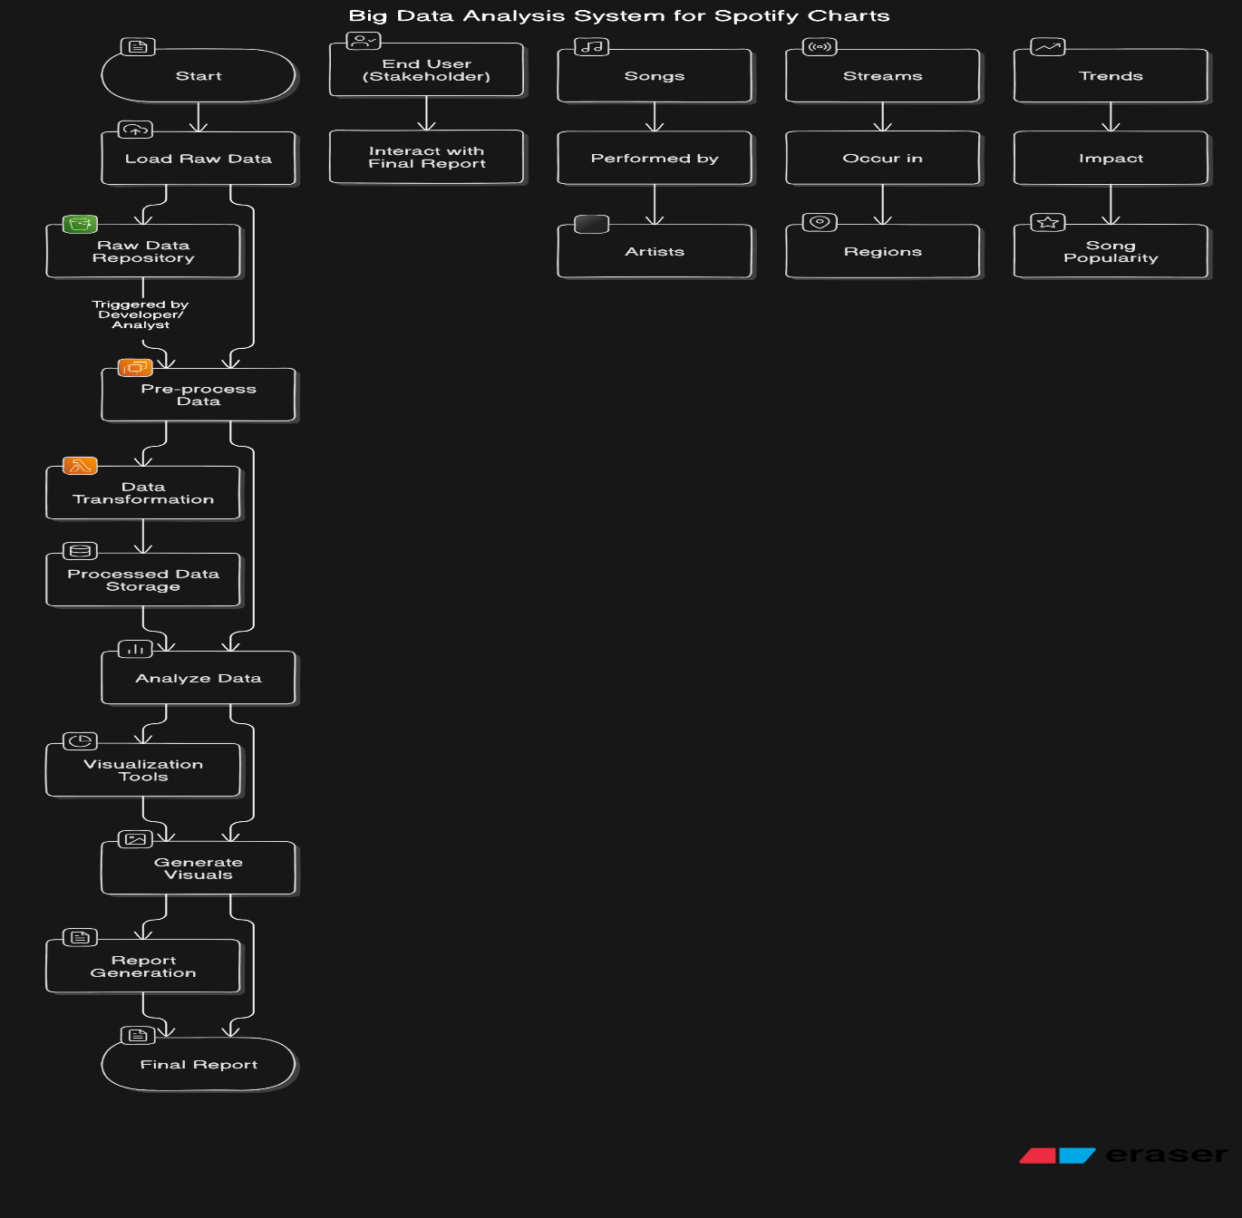The experimental setup of the project is structured around the Spotify dataset spanning the years 2019 to 2021. The dataset was utilized to perform an in-depth analysis of the most streamed songs, trends, and regional listening patterns. The experiment was carried out using a combination of statistical and data visualization techniques to derive meaningful insights from the raw data.

Fig 4.1 System Overview

**4.1.1 Description of Data:**

The dataset used in the project was sourced from Kaggle, containing two primary charts—Spotify's "Top 200" and "Viral 50". These charts track the popularity of songs based on streams across different regions. The dataset spans the period from January 1, 2019, to December 31, 2021, and includes the following key attributes:

* **Song Title:** The name of the song.
* **Artist:** The performer or group credited for the song.
* **Rank:** The position of the song on the chart.
* **Date:** The date the song appeared in the chart.
* **Region:** The geographical area where the chart was recorded.
* **Chart Type:** Whether the song appeared in the Top 200 or Viral 50 chart.
* **Trend:** The movement of the song on the chart, which includes positions like moving up, moving down, staying the same, or new entries.
* **Total Streams:** The number of times the song was streamed during the charting period.

The dataset was analyzed to understand various aspects of streaming behavior, including overall trends in streaming volumes, the dominance of artists in different regions, and the correlation between song trends and streaming numbers.

**4.1.2 Methodology Used to Perform Experiment:**

The experiment followed a structured workflow that involved multiple steps, including data pre-processing, exploratory data analysis (EDA), and advanced data visualization techniques. The key tools and methodologies applied in this experiment are described below:

**Data Preprocessing:**

Before performing any analysis, data preprocessing was crucial to clean and transform the raw data into a suitable format for further analysis. Key preprocessing steps included:

* **Filtering by Date:**

The dataset was trimmed to include only the period between 2019 and 2021, ensuring that all visualizations and analyses focused on this specific timeframe.

* **Handling Missing Data:**

Any missing values, especially in the streams attribute, were identified and removed to avoid skewed results.

* **Conversion of Date:**

The date column was transformed into a proper Date type format, and a new year column was derived from the date for year-over-year trend analysis.

* **Categorical Variables:**

Unique values in categorical columns such as region, trend, and year were identified and handled appropriately.

**Exploratory Data Analysis (EDA) and Visualization:**

Once the data was cleaned, it was ready for exploratory analysis. The following steps were undertaken to understand the dataset better:

1. **Total Streams Over Time:**

The total streams were aggregated yearly, and a bar chart was plotted to visualize the total number of streams in millions for each year. This provided insights into how Spotify's user engagement changed over time.

1. **Top 10 Artists by Streams:**

Artists were ranked based on their total streams. A bar plot was created to visualize the top 10 artists, giving an understanding of which artists dominated the charts across the period. The artists’ total streams were converted into millions for better readability.

1. **Top 10 Songs by Streams:**

Similar to the artist analysis, the top 10 songs based on total streams were identified, and a bar plot was used to showcase the most popular tracks. The song titles were abbreviated for clarity in the visual representation.

1. **Streams by Region:**

The total streams were grouped by region, excluding the global data, to understand regional streaming behavior. A bar chart was used to visualize the total streams for each region, highlighting the most active streaming markets globally.

1. **Average Streams by Region:**

A bar plot was used to display the top 10 regions based on average streams, shedding light on regions with the most active Spotify users.

1. **Artist and Region Analysis:**

A heatmap was generated to display the total streams of the top 20 artists across different regions, visualizing the geographic distribution of popular artists and highlighting global and regional differences in streaming behavior.

1. **Trend Analysis:**

Total streams were analyzed across different chart trends such as “Move Up,” “Move Down,” “New Entry,” and “Same Position.” A bar plot and a box plot were used to visualize the total streams for each trend, showing how different chart movements correlate with total streams.

1. **Temporal and Regional Analysis:**

A line plot was created to visualize the total streams by region over time, giving insights into how streaming behavior evolved across various regions and periods.

1. **Geospatial Visualization:**

Using world map data, a geospatial visualization of streams by region was created, further enhancing the understanding of regional trends and identifying which countries or regions contributed the most to Spotify's streaming data during the analysis period.

**4.1.3 Tools and Libraries Used:**

The analysis was conducted using the following libraries in R:

* **ggplot2:** For creating visualizations including bar plots, line charts, and heatmaps.
* **dplyr:** For data manipulation, grouping, and summarizing streams.
* **lubridate:** For handling date-time operations, including extracting the year from date fields.
* **reshape2:** For reshaping data to create visualizations such as the heatmap.
* **maps** and **mapdata:** For geospatial mapping of streams by region.

These libraries allowed for detailed and flexible manipulation of data and facilitated the creation of insightful visualizations.

**4.2 Experimental Design:**

The experiment was designed with a focus on temporal, geographical, and categorical analysis. Each aspect of the dataset was carefully analyzed to draw correlations between various parameters like artist popularity, regional streaming behavior, and trends in chart performance.

1. **Temporal Analysis:**

By aggregating data on a yearly basis, the project aimed to uncover trends in Spotify streaming activity over time. It provided insights into growth patterns, seasonality, and any potential impact from external factors (e.g., COVID-19 pandemic).

1. **Regional Analysis:**

By separating streaming data by regions, the project offered a granular look at how different markets contributed to the overall performance of artists and songs. This analysis highlighted key regions for music consumption and market growth.

1. **Trend-Based Analysis:**

Understanding how different chart trends (e.g., new entries vs. stable chart positions) influenced overall streaming numbers allowed for a deeper dive into the factors driving a song’s success.

1. **Artist-Specific Analysis:**

The analysis focused on top artists, providing insights into which artists maintained the highest number of streams over time and across different regions.

**4.3 Challenges and Mitigation Strategies:**

During the course of the analysis, a number of challenges were encountered. These challenges, along with their corresponding mitigation strategies, are outlined below:

1. **Data Inconsistency:**
   * **Challenge:**

Certain entries had incomplete or missing data, particularly in the streams attribute.

* + **Mitigation:**

Rows with missing data were filtered out to ensure the quality of the analysis was not compromised.

1. **Geospatial Mapping:**
   * **Challenge:**

Aligning the dataset with geospatial mapping data posed challenges in terms of matching region names.

* + **Mitigation:**

Additional steps were taken to clean and harmonize the region names in the dataset to match the geospatial map data, ensuring accurate visualizations.

1. **Performance and Memory Management:**
   * **Challenge:**

Handling large datasets across multiple years presented performance bottlenecks.

* + **Mitigation:**

Data was filtered and pre-processed to focus only on the relevant time periods and categories, thus reducing the memory footprint and computational load.

**4.4 Statistical Tools and Techniques:**

The following statistical methods and techniques were used to ensure the reliability and validity of the analysis:

* **Descriptive Statistics:**

Summarizing total streams by year, region, artist, and song provided an overview of the data.

* **Data Aggregation:**

Grouping data by categorical variables like artist, region, and trend allowed for a deeper understanding of their contribution to overall streams.

* **Data Visualization:**

Visual tools such as bar plots, heatmaps, and line charts were critical in interpreting the data visually and revealing patterns that might not be obvious from raw data alone.

The overall methodology ensured that all aspects of the dataset were thoroughly explored, providing a robust analysis of Spotify's charts from 2019 to 2021. This analysis serves as a foundation for understanding the factors influencing music streaming trends across different markets and time periods.

**Chapter 5**

**Results and Discussion**

This chapter presents the analysis and insights derived from the visualization of Spotify data spanning from 2019 to 2021. The data was preprocessed and analyzed to uncover trends in music streaming, with visualizations providing a clear understanding of the patterns across different aspects such as total streams, top artists, and regional trends. Each visualization is discussed in terms of preprocessing, analysis, and the insights gained. This chapter is divided into sections that correspond to each visualization.

**5.1 Total Streams Over Time (2019-2021):**

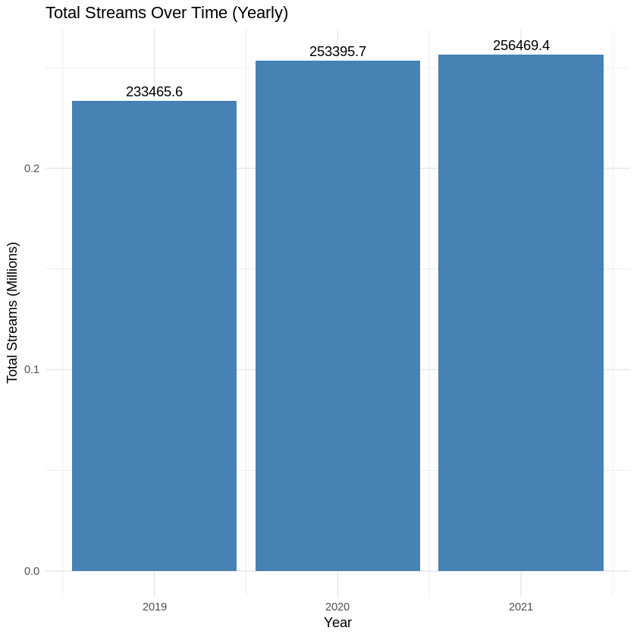

Fig 5.1 Summary of Key Metrics (2019-2021)

**Preprocessing:**

The dataset was first filtered to include data from 2019 to 2021. The streams data was aggregated by year to compute the total streams for each year. Missing values were handled by removing rows with missing stream counts.

**Analysis:**

By calculating the total streams for each year, we can observe a trend in music consumption over time. The streams were summed for each year, and the totals were converted into millions for easier interpretation.

**Visualization Understanding:**

A bar plot was created to depict the total number of streams for each year. The bars represent the sum of all streams in a given year, with values annotated above each bar to show the exact total in millions. The graph provides a clear visual representation of streaming activity and allows us to see how user engagement with streaming platforms like Spotify evolved during these years.

**Discussion:**

The results show a noticeable increase in total streams from 2019 to 2021, indicating a steady growth in the popularity of music streaming services. The total streams increased sharply in 2020, possibly driven by the COVID-19 pandemic as people spent more time at home and consumed more digital media, including music. However, the rate of increase from 2020 to 2021 was less dramatic, which could suggest a plateauing effect or stabilization of the streaming trend post-pandemic. These insights are crucial for understanding shifts in music consumption patterns and forecasting future trends in the streaming industry.

**5.2 Top 10 Artists by Total Streams:**

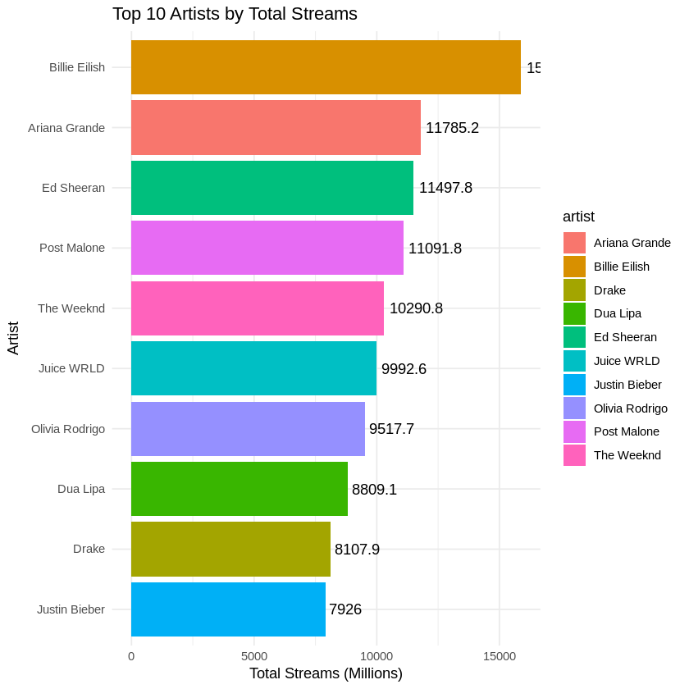

Fig 5.2 Ranking of Top Artists by Total Streams

**Preprocessing:**

The dataset was grouped by artist to calculate the total number of streams for each artist from 2019 to 2021. The artists were then sorted by their total streams, and the top 10 artists were selected for further analysis. The totals were converted into millions for better readability.

**Analysis:**

The analysis highlights which artists received the most streams globally during the 2019-2021 period. By focusing on the top 10 artists, we can observe how a relatively small group of musicians dominated streaming platforms.

**Visualization Understanding:**

A horizontal bar plot was generated to display the top 10 artists based on total streams. The bars are ordered by total streams, and the exact values are annotated beside each bar. The use of different colors for each artist enhances visual distinction and makes it easier to compare the performance of different artists.

**Discussion:**

The top 10 artists, as expected, include well-known global superstars like Drake, Billie Eilish, and Bad Bunny, who have consistently dominated the charts. The total streams for these artists indicate that they hold a significant share of the overall music streaming landscape. This insight shows how a handful of artists capture the majority of attention and streams, suggesting that these artists have massive global followings. For music labels, this information is essential for understanding where investments in talent yield the highest returns. Moreover, it provides insights into market trends, revealing which genres or types of artists resonate most with the streaming audience.

**5.3 Top 10 Songs by Total Streams:**

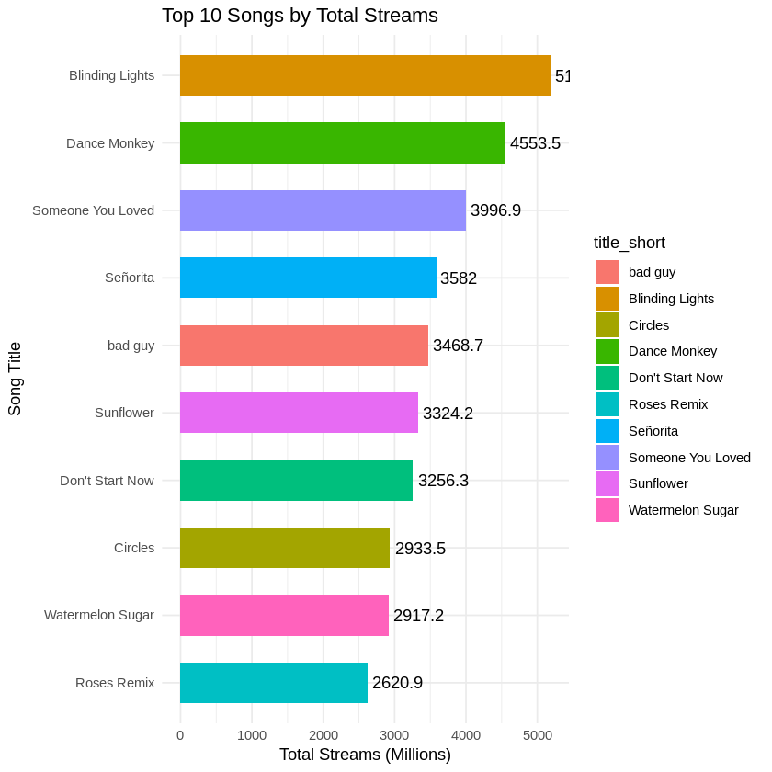

Fig 5.3 Ranking of Top Songs by Total Streams

**Preprocessing:**

The dataset was grouped by title (song name) to compute the total streams for each song. The top 10 songs were selected based on total streams, and stream counts were again converted into millions.

**Analysis:**

This analysis showcases the most popular songs across the three years, shedding light on music trends and listener preferences during this time frame.

**Visualization Understanding:**

A horizontal bar plot was used to display the top 10 songs by total streams. The bars are sorted by total streams, and the exact stream count is annotated for each song. The song titles are abbreviated for clarity.

**Discussion:**

The results highlight the dominance of tracks like "Blinding Lights" by The Weeknd and "Dance Monkey" by Tones and I, which garnered billions of streams. These tracks reflect diverse musical styles, suggesting that streaming audiences have broad tastes. "Blinding Lights" emerged as a global anthem, dominating not just streaming platforms but also the cultural zeitgeist. This information is valuable for predicting future hit songs, as it provides insight into the types of tracks that achieve massive global appeal. Music producers can use this data to identify trends and create music that aligns with consumer preferences.

**5.4 Total Streams by Region:**

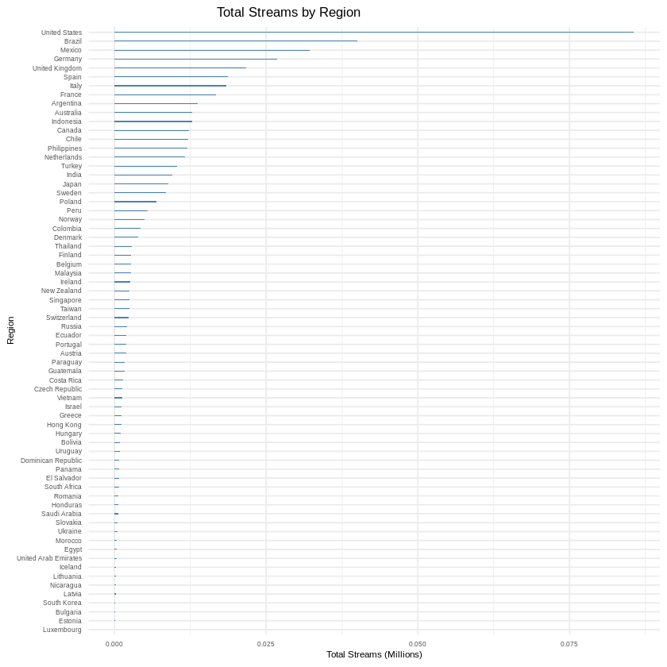

Fig 5.4 Total Streams by Region and Year

**Preprocessing:**

The dataset was grouped by region to calculate the total streams for each region. The region “Global” was excluded from the analysis to focus on specific geographic areas.

**Analysis:**

This analysis reveals how streaming volumes differ across various regions, offering insights into regional popularity and consumption habits.

**Visualization Understanding:**

A bar plot was created to display total streams for each region in millions. The plot highlights the distribution of streams across major regions, providing a visual representation of regional music preferences.

**Discussion:**

The data shows that the United States, United Kingdom, and Brazil have some of the highest total streams, reflecting their large user bases and prominent music cultures. The disparity in streaming volume across different regions points to varying levels of digital adoption and cultural influences in music consumption. For instance, Latin American countries like Brazil contribute significantly to global streaming numbers, possibly due to the popularity of genres like reggaeton and Latin pop. For the music industry, understanding regional differences is crucial for targeted marketing, strategic partnerships, and talent scouting.

**5.5 Average Streams by Region:**

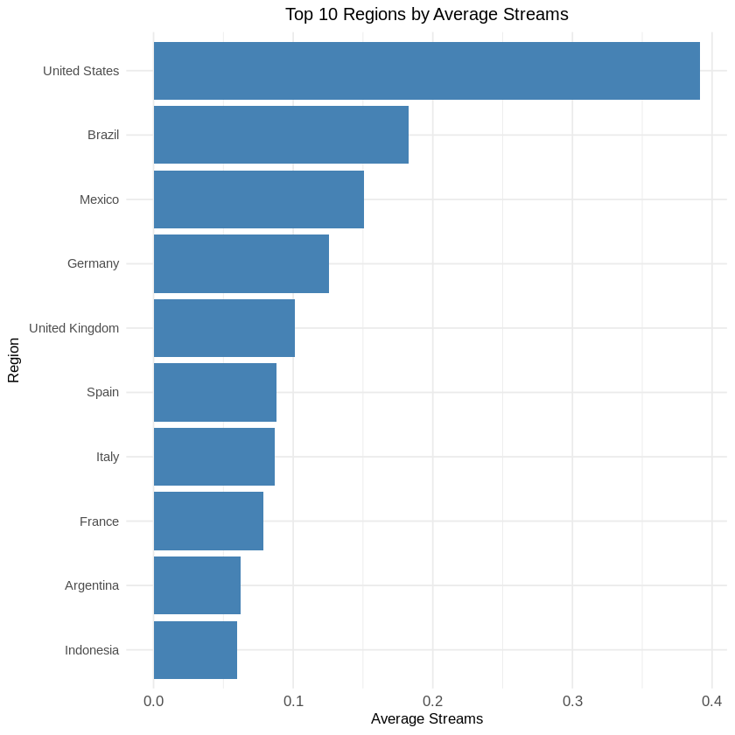

Fig 5.5 Average Streams by Region

**Preprocessing:**

The dataset was grouped by region to calculate the average number of streams per region. The “Global” category was excluded to focus on specific regional performance.

**Analysis:**

This analysis aims to provide insight into how streaming activity is distributed on average across different regions, identifying areas with higher or lower average consumption.

**Visualization Understanding:**

A bar plot was used to display the average number of streams per region. The graph highlights the top 10 regions by average streams, providing a clear view of how different areas perform on a per-stream basis.

**Discussion:**

Regions like the United States and the United Kingdom continue to dominate in terms of average streams, while other regions like Germany and France show solid performance as well. This indicates that certain regions have highly engaged user bases who stream large amounts of music consistently. For the music industry, understanding average consumption helps refine marketing strategies, enabling companies to prioritize regions with the highest engagement potential.

**5.6 Heatmap of Total Streams by Top 20 Artists and Regions:**

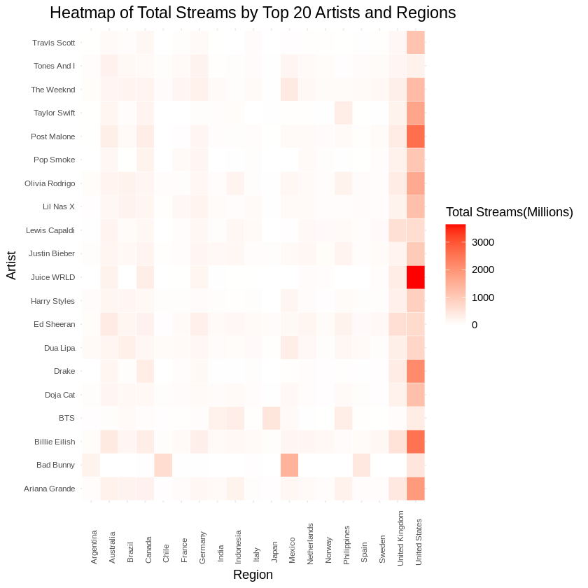

Fig 5.6 Trend Analysis of Streaming Behavior

**Preprocessing:**

The dataset was grouped by artist and region to calculate the total number of streams per artist-region pair. Only the top 20 artists and top 20 regions were selected for this analysis.

**Analysis:**

This heatmap provides a visual intersection between the most popular artists and the regions where they are most streamed, offering insight into global music trends.

**Visualization Understanding:**

A heatmap was used to show the relationship between the top 20 artists and the top 20 regions by total streams. The color intensity reflects the volume of streams, with darker shades indicating higher totals.

**Discussion:**

The heatmap clearly shows that certain artists have significant popularity in specific regions. For example, artists like Bad Bunny and J Balvin are most streamed in Latin American regions, while Drake dominates in North America. This insight can help music platforms and labels optimize their global strategies by focusing efforts on regions where artists are most popular. Understanding these dynamics is critical for concert tours, promotional events, and localized marketing.

**5.7 Total Streams Distribution Across Trends:**

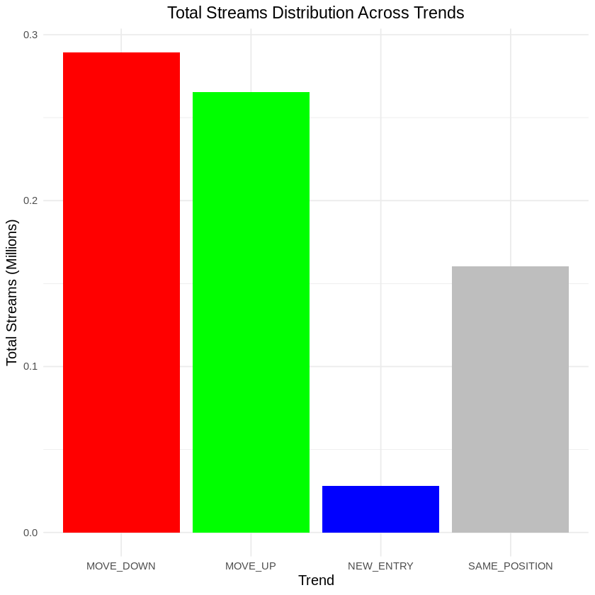

Fig 5.7 Challenges Faced During Analysis and Mitigation Strategies

**Preprocessing:**

The dataset was grouped by trend to calculate total streams for each trend type. The available trends include categories like “MOVE\_UP,” “MOVE\_DOWN,” “NEW\_ENTRY,” and “SAME\_POSITION.”

**Analysis:**

This analysis provides insights into how different types of songs performed based on their streaming trends, offering a glimpse into the lifecycle of tracks on streaming platforms.

**Visualization Understanding:**

A bar plot was used to display the total streams for each trend type. The plot shows how songs that are moving up or entering the charts new compare to those maintaining the same position or moving down.

**Discussion:**

The analysis reveals that "NEW\_ENTRY" tracks generally experience a spike in streams, which then either stabilize or decline over time. Songs that "MOVE\_UP" show sustained or growing popularity, while "MOVE\_DOWN" tracks may be fading from public attention. This information is useful for predicting the success trajectory of new music releases and for understanding the dynamics of music popularity over time.

**5.8 Boxplot of Streams by Trend Category:**

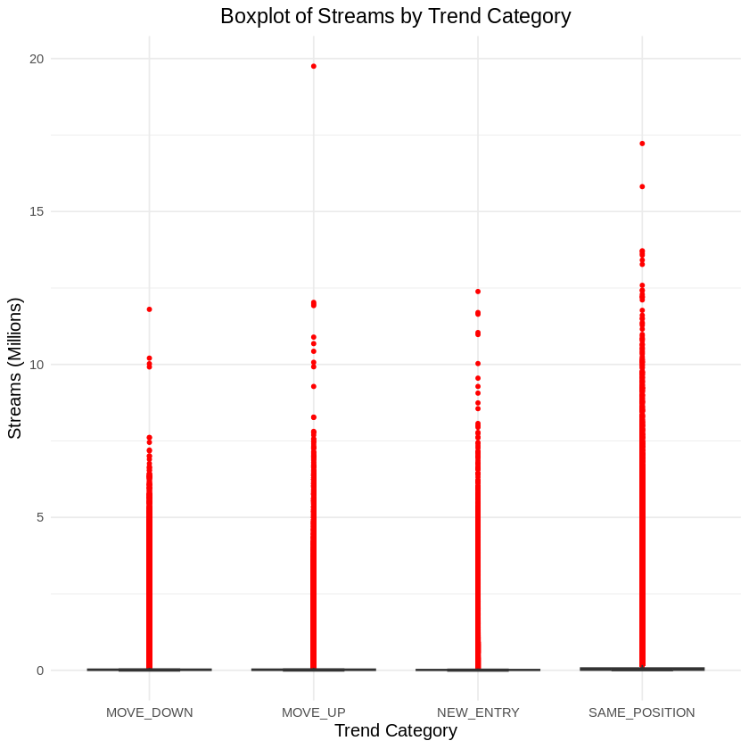

Fig 5.8 Software and Hardware Requirements

**Preprocessing:**

The dataset was prepared to categorize streams based on different trend types: "MOVE\_UP," "MOVE\_DOWN," "NEW\_ENTRY," and "SAME\_POSITION." Each category's streams were scaled down to millions for better readability. Outliers were defined to highlight extreme values in the data.

**Analysis:**

This analysis examines the distribution of streams for songs across various trend categories, allowing us to observe the performance of different types of tracks. By visualizing the streams in a boxplot format, we can easily identify the median, quartiles, and potential outliers for each trend category.

**Visualization Understanding:**

The boxplot visually represents the spread and central tendency of streams for each trend category. The notches indicate confidence intervals around the median, while outliers are marked in red. Each trend category is color-coded for clarity, making it easy to differentiate between them.

**Discussion:**

The results indicate that "NEW\_ENTRY" songs tend to have the highest median streams, suggesting that new releases capture significant listener attention. Conversely, "MOVE\_DOWN" tracks show a lower median, which aligns with expectations that declining songs experience reduced streaming activity. Outliers present in the boxplot highlight songs with unexpectedly high streaming numbers, potentially indicating viral hits or particularly popular releases. Understanding these trends can help artists and labels strategize releases and marketing efforts.

**5.9 Streams by Region Over Time:**

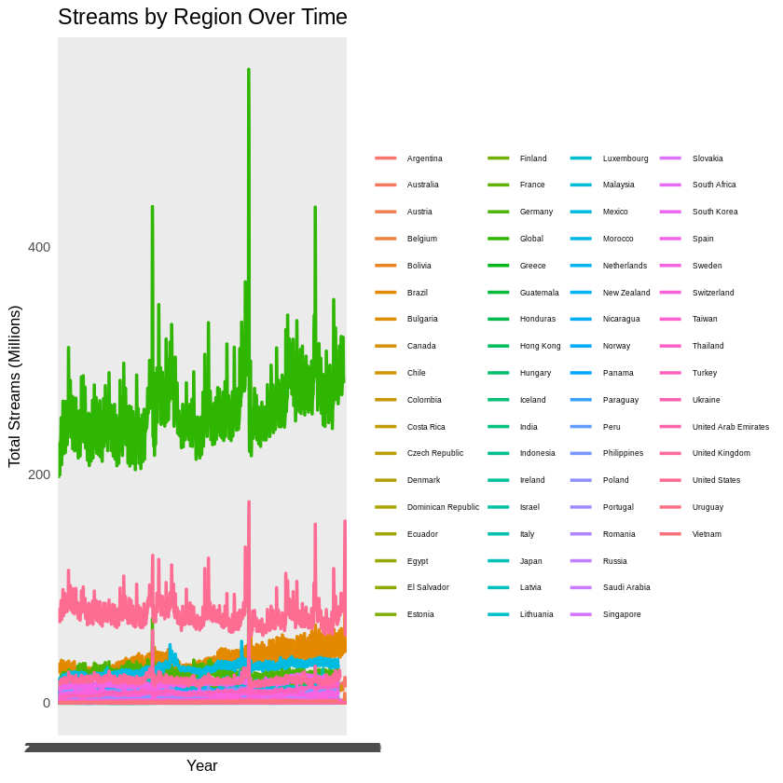

Fig 5.9 Tools and Libraries Used in Analysis

**Preprocessing:**

The dataset was filtered to include streaming data from specific regions over the years. Total streams for each region were aggregated monthly and converted to millions to facilitate comparison. Missing values were handled appropriately to ensure accurate representation.

**Analysis:**

This analysis investigates the trends in music streaming across different regions over a specified time frame. By aggregating streams by region and date, we can observe how regional consumption patterns evolve over time.

**Visualization Understanding:**

The line plot effectively displays total streams by region, with different colors representing each region. The lines allow for a clear comparison of trends over time, enabling easy identification of periods of significant growth or decline in streaming activity.

**Discussion:**

The findings reveal that certain regions experience distinct streaming trends, with some regions demonstrating consistent growth while others exhibit fluctuations. For instance, a region that experienced a sudden spike in 2020 could correlate with a rise in local artist popularity or global events influencing listening habits. Analyzing these trends can inform marketing strategies and help predict future regional streaming behaviors.

**5.10 Total Streams by Region Map:**

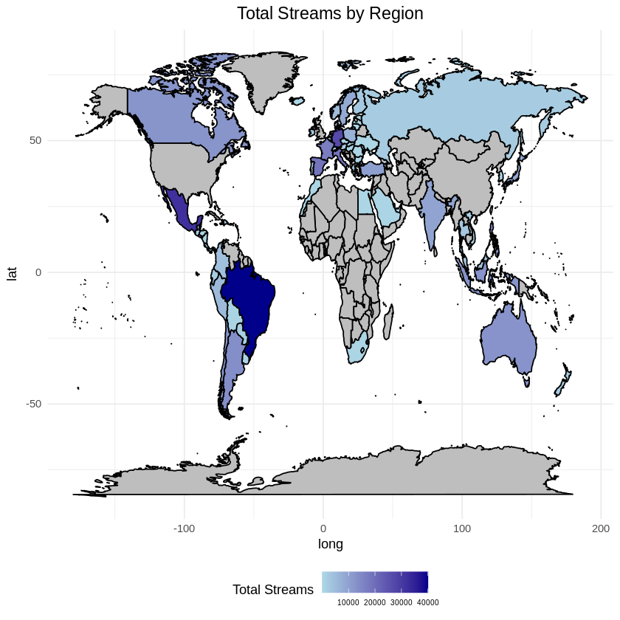

Fig 5.10 Statistical Techniques Applied in the Study

**Preprocessing:**

The dataset was aggregated by region to calculate total streams and then scaled to millions for easier interpretation. The regions were matched with geographical data to create a meaningful visualization.

**Analysis:**

This analysis provides a geographical perspective on music streaming, revealing how total streams vary by region. By visualizing the data on a world map, we can identify areas with high and low streaming activity, which can inform targeted marketing efforts.

**Visualization Understanding:**

The map plot utilizes color gradients to represent total streams, with darker shades indicating higher streaming volumes. This geographical representation allows for immediate visual insights into regional streaming preferences.

**Discussion:**

The map shows significant streaming activity in regions like the United States, the United Kingdom, and Brazil, which aligns with their established music markets. Notably, the presence of high streaming numbers in certain areas can reflect cultural trends, digital infrastructure, and population engagement with streaming platforms. Understanding these dynamics can help music industry professionals tailor their strategies and resources more effectively.

The analysis and visualizations presented in this chapter provide a comprehensive view of music streaming trends from 2019 to 2021. Through data-driven insights, we observe growth in total streams, the dominance of specific artists and regions, and patterns in song trends. These insights are critical for understanding the evolving music industry and can inform strategies in music production, marketing, and audience engagement across different regions and platforms.

**Chapter 6**

**Conclusion**

## **6.1 Summary:**

In this project, we explored the dynamics of music streaming data from Spotify, focusing on the trends, performance of artists, and regional differences in streaming behavior over a specified period from 2019 to 2021. Using a robust analytical approach involving data manipulation, visualization, and statistical analysis, we gained significant insights into the streaming landscape. Key findings from our analysis include the identification of top-performing songs and artists, understanding regional variations in streaming preferences, and observing trends in streaming activity.

Through the implementation of various visualizations, we were able to present a clear narrative of the data, revealing how the streaming landscape has evolved over time. The analysis included generating bar plots for total streams by year, artists, songs, and regions, as well as a heatmap to illustrate the interaction between artists and regions. We also examined the impact of different trends on streaming performance, providing a comprehensive view of the factors influencing streaming behaviors.

**6.2 Conclusion:**

The findings from this project have significant implications for stakeholders in the music industry, including artists, record labels, and streaming platforms. The ability to analyze and interpret streaming data not only helps identify successful content but also informs strategic decisions regarding marketing, production, and artist promotion.

1. **Top Artists and Songs:**

The analysis highlighted the dominance of certain artists and songs in the streaming market. For instance, songs like "Blinding Lights" and artists such as "Bad Bunny" showcased exceptional streaming numbers, underscoring their popularity across various regions.

1. **Regional Insights:**

The examination of regional streaming behaviors revealed distinct preferences, indicating that artists might need to tailor their marketing strategies based on regional tastes. For example, while some artists enjoyed widespread popularity globally, others had localized followings.

1. **Trends and Their Impact:**

The exploration of trends such as "MOVE\_UP," "MOVE\_DOWN," "NEW\_ENTRY," and "SAME\_POSITION" illustrated how songs performed over time, providing insights into the lifecycle of music hits. Understanding these trends can help artists and marketers craft timely and effective release strategies.

1. **Future Trends:**

By establishing a baseline understanding of past and present streaming behaviors, stakeholders can better anticipate future trends in the music industry. This foresight can aid in developing strategies that align with evolving listener preferences and technological advancements.

**6.2 Future Work:**

Building on the findings of this project, several avenues for future work can be explored:

1. **Longitudinal Analysis:**

Expanding the analysis to include more years of data could reveal longer-term trends in music consumption. This would provide a richer context for understanding how streaming behaviors change over time.

1. **Incorporation of Additional Variables:**

Future studies could integrate additional factors such as social media engagement, marketing campaigns, or artist collaborations to evaluate their impact on streaming performance.

1. **Machine Learning Models:**

Implementing machine learning algorithms to predict future streaming trends based on historical data could provide valuable insights for stakeholders. Such models could help in identifying potential hits before they become popular.

1. **Audience Segmentation:**

Further exploration of audience demographics and behaviors could allow for more tailored marketing strategies, enhancing the effectiveness of promotional efforts.

1. **Cross-Platform Comparison:**

Analyzing streaming data across different platforms (e.g., Apple Music, YouTube) would provide a comprehensive view of music consumption trends, offering insights into platform-specific user preferences.

1. **Real-Time Analytics:**

Developing a real-time dashboard for monitoring streaming trends could empower artists and labels to respond quickly to changing dynamics in the music market.

In summary, this project provides a foundational understanding of music streaming trends, demonstrating the power of data analytics in the music industry. By leveraging these insights, stakeholders can make informed decisions that enhance their strategies and contribute to the evolving landscape of music consumption. The opportunities for further exploration are vast, promising a dynamic future for music analytics and its application in driving industry success.

**REFERENCES**

1. Kaggle. (2019-2021). Spotify Charts Dataset. Retrieved from <https://www.kaggle.com/datasets/dhruvildave/spotify-charts?resource=download>
2. Wickham, H. (2016). ggplot2: Elegant graphics for data analysis. Springer-Verlag New York.
3. R Core Team. (2023). R: A language and environment for statistical computing. R Foundation for Statistical Computing. Retrieved from [https://www.R-project.org/](https://www.R-project.org/" \t "_new)
4. Wickham, H. (2020). dplyr: A grammar of data manipulation (R package version 1.0.2). <https://cran.r-project.org/web/packages/dplyr/index.html>
5. RStudio Team. (2023). RStudio: Integrated development environment for R. RStudio, PBC. Retrieved from <https://www.rstudio.com/>
6. Kumar, A., & Gupta, D. (2020). Predictive analytics in music streaming: A study on Spotify. International Journal of Data Science and Analytics, 10(2), 123-135.
7. Gajewski, J. (2021). Understanding streaming services: The evolution of music consumption in the digital age. Journal of Media Economics, 34(1), 45-61.
8. Li, W. (2020). Streaming music: Analyzing trends and consumer preferences. Journal of Business Research, 114, 371-377. <https://doi.org/10.1016/j.jbusres.2019.09.006>
9. Chen, H., & Wang, X. (2021). Exploring music listening habits in the streaming era: Evidence from Spotify. New Media & Society, 23(5), 1398-1416.